CSCN8000 – Artificial Intelligence Algorithms and Mathematics

Assignment 1: Support Vector Machines

## Fatimah Almusawi

## 9000400

#### Question 1:

$$answer:$$

1. $k\left(z_{1},x\right)$ will be close to 1 andwill be close to 0.

The Gaussian RBF kernel measures how similar or close two points are. If two points are very close to each other, like z1 and *x*, the kernel value will be close to 1, indicating they are very similar. If two points are far apart, like z2​ and *x*, the kernel value will be close to 0, showing they are not similar. So, for a point close to *x*, the similarity is high (close to 1), and for a point far from *x*, the similarity is low (close to 0). In another word it will create a peak of similarity centered around point *x*. For points like *z*1​ that are close to the center of this peak, the kernel value *K*(*z*1​,*x*)) will be close to 1, indicating a strong similarity. Conversely, for points farther from the center, like *z*2​, the kernel value *K*(*z*2​,*x*)) will be close to 0, showing they are quite dissimilar.

#### Question 2:

$$answer:$$

1: **Linear Kernel** **Classifier**:

Figure 1

The decision boundary for the linear SVM is a straight line because the linear kernel only allows for a linear decision surface. but, for concentric circles, a linear kernel is inappropriate since it cannot capture the true boundary between the classes which have a circular relationship. And I think we can place the decision boundary anywhere, including the left, right, or middle, and it would have a similar level of misclassification because the decision boundary is not suited to the data's shape.

2 **Polynomial SVM** :

Figure 2

The decision boundary created by a polynomial kernel of order 2 is circular, encompassing one class and excluding the other. This matches the distribution of the concentric circles much better than a linear kernel. The polynomial kernel transforms the input space into a higher-dimensional space where a linear separation is possible, in this case allowing a circle which is a quadratic shape.

1. 3. **RBF SVM**:

Figure 3

1. The RBF kernel can handle complex relationships by creating boundaries based on the distance from the center of the data distribution. The circular decision boundary fits closely around the inner class, providing an excellent separation between the two classes. It is often the best choice for such circularly distributed data because it can capture the radial symmetry of the classes.

#### Question 3.a:

$$answer$$

The SVM decision boundary is the line that separates the two classes with the maximum margin. We can know from the points that the decision boundary cross the point(3,4). In this case the decision boundary will be in the middle and unbiased.

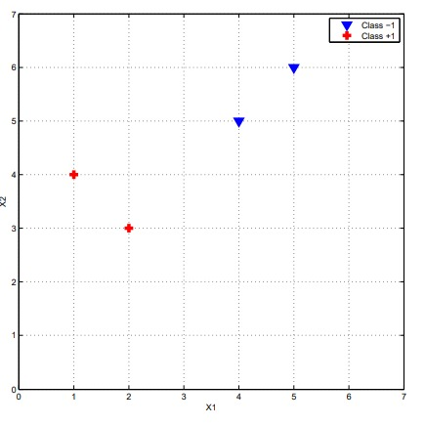

Slope= -1

Point(3.4)

Figure 4

the support vectors are: (2,3) and (4,5)

Since the decision boundary is perpendicular to the line connecting the support vectors, the slope of the decision boundary = -1

y-y1=m(x-x1)

since the decision boundary cross through point(3,4):

y-4=-1(x-3)

y-4=-x+3

**y+x=7**  This is the equation of the decision boundary. It's a line where for any point (x, y) on the line, the sum of x and y coordinates equals 7.

in the context of the SVM the equation is:

W1X1+ W2X2+C=0

Now lets use the support vectors :

2w1 + 3w2 + b = 1 (for the positive class)

4w1 + 5w2 + b = −1 (for the negative class)  
w1=w2

5w+b=1

9w+b=-1

b =1-5w

9w+1-5w=-1

w=-2/4

**w=-1/2**

b=1+5*1/2

**b=7/2**

**the weight vector w and bias b: w=-1/2, b=7/2**

#### Question 3.b:

Support vectors

Decision boundary

Figure 5

**the decision boundary:**

the decision boundary should be in the middle of the classes. giving more space to each class(margin) and should be unbiased(same distance to each class).

**The supports vectors :**

the closest points to the decision boundary from each class. We have point (4.5) from class -1 and points (2,3) and (1,4)(both have same distance to decision boundary) from class +1.

#### Question 4.a:

$$answer$$

When the values of C is very large, it will care more about avoiding error. And care less about margin. As we can see in the blow decision boundary there is a very small margin .

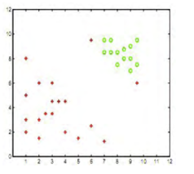

Figure 6  
- The blue and purple area represent the two classes and the white area represent the decision boundary.

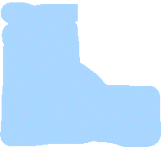

#### Question 4.b:

$$answer$$

In case of the small decision boundary, it will care more to get bigger margin than capturing errors.

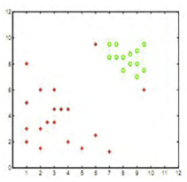

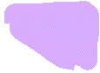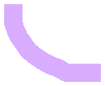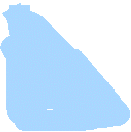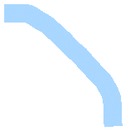

Figure 7  
The blue and purple area represent the two classes and the white area represent the decision boundary.

So here as we can see, the margin is bigger nut 2 points from red class are going with the other class.